//www.aranacorp.com/fr/votre-arduino-communique-avec-le-module-hc-05/

Adresse Mac du HC05 : 20:26:01:00:16:53
Nom : HC-05
Pwd : 1234

Schema pour configuer le HC05 : Definition du nom, pwd, mode, récupérer adresse Mac\
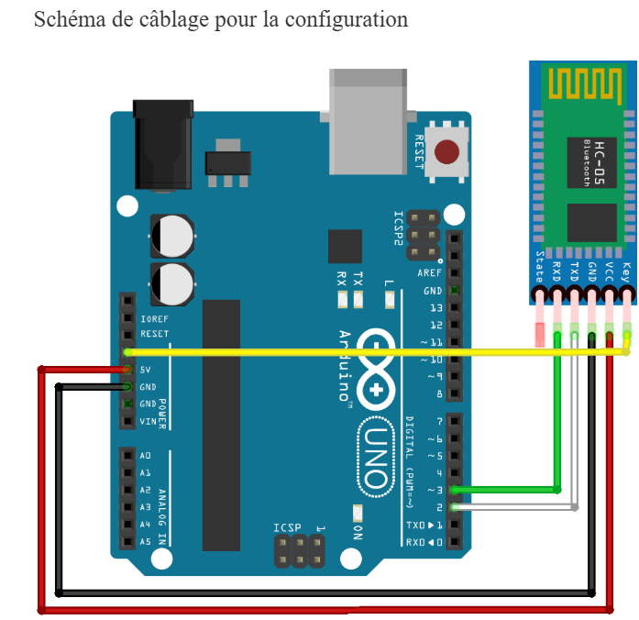

AT Commande
Test
Command Response Parameter
Commande | Reponse | Parameter
AT | OK | None

Reset
Commande | Reponse | Parameter
AT+RESET | OK | None

Get the soft version
Commande | Reponse | Parameter
AT+ VERSION? | OK | None

Restore default status
Commande | Reponse | Parameter
AT+ORGL | OK | None

Get Address Mac
Commande | Reponse | Parameter
AT+ADDR? | +ADDR: <Addres Mac>
Module Bluetooth address: 12: 34: 56: ab: cd: ef
at+addr?\r\n
+ADDR:1234:56:abcdef
20:26:01:00:16:53

Set/ inquire device’s name
Commande | Reponse | Parameter
AT+NAME=<Param> | AT+NAME=<Param> OK
AT+NAME? | 1. +NAME:<Param>  OK----success  2. FAIL----failure | Param: Bluetooth device name  Default: “HC-05”

8. Set/ inquire module role
Commande | Reponse | Parameter
AT+ROLE=<Param> | OK | Param:  0---- Slave role  1---- Master role  2---- Slave-Loop role  Default: 0
AT+ ROLE? | + ROLE:<Param>  OK

13.Set/ Inquire- serial parameter
Commande | Reponse | Parameter
AT+UART=<Param>,<  Param2>,<Param3> | OK | Param1: baud rate( bits/s)  The value (Decimal) should  be one of the following:  4800  9600  19200  38400  57600  115200  23400  460800  921600  1382400  Param2:stop bit:  0----1 bit  1----2 bits  Param3: parity bit  0----None  1----Odd parity  2----Even parity  Default: 9600, 0, 0
AT+ UART? | UART=<Param>,<Para  m2>,<Param3>  OK

12. Set/Inquire- passkey
Commande | Reponse | Parameter
AT+PSWD=<Param> | OK | Param: passkey  Default: “1234”
AT+ PSWD? | + PSWD : <Param>  Ok

Schéma en fonctionnement nominal
